

GEOGRAPHY

©Tzshule | tzshule@gmail.com | Call/WhatsApp +255 718 451 939

TABLE OF CONTENT
Introduction ………………………………………………………………………………………...
Acknowledgement.…………………………………………………………………………………
Examination 1 ……………………………………………………………………………………...
Examination 2 ……………………………………………………………………………………...
Examination 3 ……………………………………………………………………………………...
Examination 4 ……………………………………………………………………………………...
Examination 5 ……………………………………………………………………………………...
Examination 6 ……………………………………………………………………………………...
Examination 7 ……………………………………………………………………………………...
Examination 8 ……………………………………………………………………………………..
Examination 9 ……………………………………………………………………………………..
Answers of examination 1 .………………………………………………………………………..
Answers of examination 2 .………………………………………………………………………..
Answers of examination 3 .…………………………………………………………… ………….
Answers of examination 4 .…………………………………………………………… ………….
Answers of examination 5 .…………………………………………………………… …………..
Answers of examination 6 .…………………………………………………………… …………..
Answers of examination 7 .…………………………………………………………… …………
Answers of examination 8 .…………………………………………………………… …………
Answers of examination 9 .…………………………………………………………… …………

INTRODUCTION

This paper consists of Geography series of examinations (for form four students). All exams have been composed based on the current recommend format from National Examination Council of Tanzania (NECTA) for the year of 2022. Some exams have been collected and reorganized from regional mock exams conducted in the year of 2020 and 2021.
The paper Aim to exposure students to variety of questions and how to attempt questions properly. Also, will help students to adapt new format as recommended by NECTA toward their final examination.
Not only students but also teachers can use it as teaching and learning material during their teachings.

ACKNOWLEDGEMENT

First and foremost, we would like to praise and thank God, the Almighty, who has granted countless blessing, knowledge, and opportunity to the Tzshule Team, so that we have been finally able to accomplish the work.
Secondly, we would like to thank CEO & Founder of Tzshule (Mr. George Ramadhani ) for not giving up on his dream of developing and providing educational materials electronically throughout the country.
We'd also like to thank all Tzshule Users for your support and positive feedback, since it motivates and encourage us to do more and more in developing educational materials.

- GOD MAY BLESS YOU ALL -

©Tzshule - 2022 “Learn & Achieve”
******************************************************** Our motto:
“Quality education, for future Generation”

QUESTIONS
THE UNITED REPUBLIC OF TANZANIA PRESIDENT’S OFFICE
REGIONAL ADMINISTRATION AND LOCAL GOVERNMENT FORM FOUR EXAMINATION - SERIES 01
GEOGRAPHY
Time 3:00 Hrs YEAR: 2022
Instructions

- This paper consists of sections A, B and C, with total of ten (10) questions

- Answer ALL questions in section A and B and two (2) questions from section C

- Map extract of (265/2) Ilonga Sheet is provided

- Credit will be given for the use of recreant diagrams

- Write your examination number on each answer sheet you have used.

SECTION A (15 Marks)

Answer all questions in this section

- For each of the items (i) – (x), choose the correct answer from among the given alternatives and write its letter besides the item number in the answer booklet provided.

  - What is a proper name for the study of the description of the earth?
A | solar system | B | Astronomy | C | Geography
D | Environment | E | Metrology

  - You have been visited the coastal area of Bagamoyo and you find the forests with deep roots and roots project above the mud and water to absorb oxygen, what kind of forest is that?
A | Tropical forest | B | Mangrove forest | C | Coniferous forest
D | Deciduous forest | E | Temperate forest

  - If the time at town X is 15⁰E is 12:00 noon what could be the longitude town Y if it is 8:00 am?
A 15⁰E B 30⁰W C 30⁰E
D 45⁰W E 45⁰E

  - Mrs Kilua was wondering how fragments are worn out during collision against each other at Kondoa river during rainy season, her daughter tells her that process is known as ……
A | Hydraulic action | B | Attrition | C | Abrasion
D | Corrosion | E | Hydrolysis

  - The Maasai around Oldonyo Lengai mountain were wondering the way mountain vomiting fire and smoke, they believe that the mountain was possessed by bad evils, tell them is not evils but is …………..
A | Volcanic eruptions | B | Tectonic movements | C | Mass wasting
D | Fire from God | E | Faulting

  - Suppose you want to carry out a field study on the atmospheric conditions suitable for growth of maize on a farm village. What are the best weather components to be considered…?
A Rainfall and wind B Rainfall and could cover C Moisture and sunshine D Rainfall and temperature E Pressure and humidity

  - Last year people of Bukoba District experience shaking of crustal rocks which lead to destruction of properties and death of people. Where this shaking does originated inside the earth’s crust?
A | At the focus | B | At the epicentre
C | At the fault | D | At the Lake Victoria

  - The process of peeling off and falling of rock mass is called
A | Disintegration | B | Weathering | C | Mass wasting
D | Erosion | E | Exfoliation

  - Workers who were working at Government offices in Dar es salaam are now moving to Dodoma as their new offices. Identify the type of that movement
A | Migrants | B | Emigrants | C | Emigration
D | Immigration | E | Immigrants

  - Recently in Rwanda the land with their vegetation was sliding down a slope and people were busy in taking photos and wondering to that situation, tell them what type of geological process was taking place
A Erosion and deposition B Denudation and transportation
C Land slide and erosion D Mass wasting and transportation E Landslide and deposition

- Match the letter of the correct response beside the item number in the answer sheet provided.

LIST A |  | LIST B
i | Fineness and coarseness of soil particles | - Soil type  - Soil profile  - loam soil  - soil texture  - Soil structure  - Soil fertility  - Soil organic matters  - Soil chemistry  - Soil erosion  - Soil water  - Soil air
ii | Removal of materials from surface of land
iii | Vertical section of the soil to the underlying rocks
iv | Status of soil with respect to amount of elements necessary for plants growth
v | Residues that have decomposed and mixed with soil mass

SECTION B (55 Marks)

Answer all questions from this section

3 Study the map extract of Ilonga (sheet 265/2) and answer the following questions.

- Measure the distance covered by the river in kilometre from grid reference 630000 to 600979
- Use the square methods to calculate the area covered by Namihondo pond.
- With evidence, mention three (3) economic activities which may be conducted on a mapped area
- Describe the nature of relief of the area
- With one reason, suggest the type of climate
- Identify any three (3) factors which have influenced the population distribution of Ilonga town.

- Carefully study the data below which shows the exports of tea from Kilimanjaro in tones.

YEAR | TEA PRODUCTION  (In Tonnes)
1981 | 7,000
1982 | 3,000

1983 | 10,000
1984 | 5,000
1985 | 2,000
1986 | 12,000
1987 | 16,000
1988 | 6,000
1989 | 15,000
1990 | 3,500

  - Name the two simplest methods of presenting the data
  - Outline two values of presenting the data by simple methods mentioned in (a) above
  - Present the given statistical data by using divergent bar graph.

- (a) Mary is a good cartographer; she intends to produce a contoured map of Morogoro. What type of survey method would you advise her to apply?

  - Apart from producing contour maps, what is the other significance of the survey you have mentioned in (a) above

  - Mention and explain uses of any three instruments which are used in method you mentioned in (a) above

- (i) what is a research data?

  - Research is a backbone for any institution, elaborate this statement by five points.
  - Mention three differences between interview and questionnaire.

- Study carefully the photograph below then answers the questions that follow: -
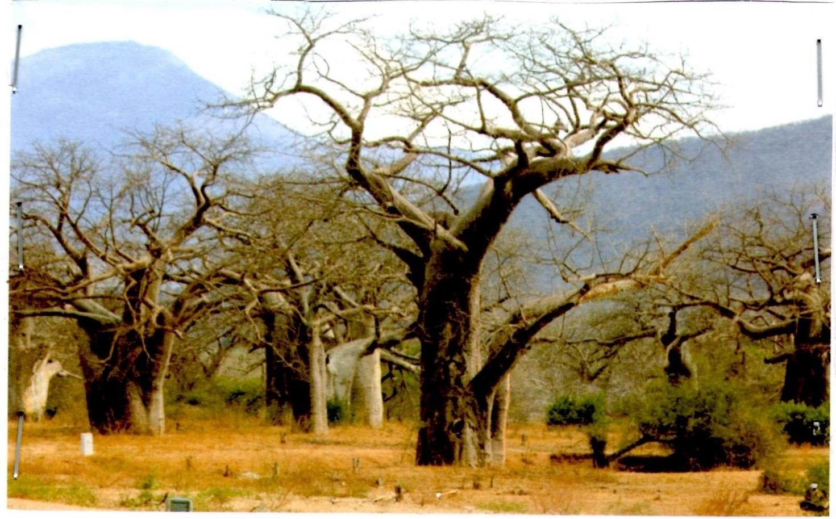

- Name the type of photograph
- Describe the possible climate of the area
- Suggest four economic activities that might be taking place in the area
- Suggest three possible regions in Tanzania where the photograph might have been taken

SECTION C. (30 Marks)

Answer two (2) questions from this section.

- Explain any six objectives of constructing the Stigler’s gorge hydro- electric power in Tanzania.

- Mage’s grandmother used to cultivate many crops in small area, using local seeds and hand hoe and now she is blaming that she harvests nothing in five years and she is complaining that her neighbours are the one who cause this problem. Explain to her six ways on how she can improve her farming system instead of complaining to her neighbours.

- Explain six human factors which influences population distribution and density in Tanzania

QUESTIONS

THE UNITED REPUBLIC OF TANZANIA PRESIDENT’S OFFICE
REGIONAL ADMINISTRATION AND LOCAL GOVERNMENT FORM THREE MIDTERM EXAMINATION - 2023
GEOGRAPHY
Time 3:00 Hrs

INSTRUCTIONS
- This paper consists of sections A, B, and C
- Answer all questions according to the instructions given
- Cellular phones and any unauthorized materials are not allowed in the examination room

SECTION A (25 Marks)

- For each of the following items (i) - (x) choose the correct answer and write its letter beside the number
  - Downward or upward movement of the earth’s crust are always given the name as …..
    - Internal earths movement ( )
    - External earths movements
    - Radial movements
    - Lateral movements
  - is a bowl shaped depression at the mouth of a volcano or geyser
    - Hot springs
    - Lava ( )
    - Crater
    - Caldera
  - Endogenic geomorphic processes includes one among the following.
    - Faulting, earthquake, weathering, folding and mass wasting.
    - Folding, mass wasting, river action and faulting
    - Joints, volcanism, mass wasting and folding. ( )
    - Folding, earthquake, faulting and volcanism
  - Farmers at Mkombozi village invited Farm officer to give them knowledge on the kind of good soil for growing maize plant. One of the knowledge he provided was about rocks permeability. Assume you are the one invited, what would you tell the farmer about permeability of rock?
    - The ability of the rock to hold water.
    - The ability of the rock to allow water to pass through. ( )
    - The rate at which water enter the rock.
    - The ability of the rock to allow water to enter it.

  - The core comprises mainly of …………………………
    - Silica and magnesium
    - Silica and aluminum ( )
    - Nickel and iron
    - Iron and magnesium
  - In de jure census, among the following can be done
- People who stay in the house hold for the night are counted
- Is only done after five years
- Only permanent members of the house hold are counted ( )
- I only done after every ten years
vii Is a chart used for dating the history of the earth including its rocks?
- Carbon 14
- Periodic table ( )
- Geological time scale
- Measurement chart
- The earth’s sphere where life takes place is called …………………………
  - Hydrosphere ( )
  - Atmosphere
  - Biosphere
  - Barrysphere
- A geography teacher was teaching her student that, the earth is inclined in its orbit at which the intensity of sun rays reach different part of the earth varies and cause the earth to experience seasonal weather changes. By relating with the revolution of the earth, what result might occur on the earth?
  - Day and night ( )
  - Deflection of wind and ocean currents.
  - Season of the year.
  - High tides and low tides
- Tanzania broadcasting cooperation TBC is used to inform the prediction of atmospheric condition in a Region for 24 to 48 hrs.Suppose you are given chance to address majority about it,which title would you used
  - Weather elements
  - Weather station
  - Weather forecasting
  - Weather report ( )

- Match the following items LIST A and that of LIST B
LIST A | LIST B
- Batholiths  - Dykes  - Lacolith  - Lopoliths  - Phacolith | - up and down movement of the surface of water  - they form dome shaped structures  - are rising and falling in the level of water in the oceans  - large saucer – shaped structures  - movement of the surface water in the ocean  - extensive areas of the ocean floor  - a raised part of the ocean floor  - is a gentle sloping margin of a continent  - is a large body of water  - formed at the crest or anticline or in the trough of syncline  - when subjected to erosion, may form escarpments  - it formed when viscious magma reach the surface through a vent  - are wall like shaped structures  - it is made of granite

SECTION B (55 marks)

Answer all questions in this section.

- Study the map extract of Mpwapwa (sheet 163/4) and answer the following questions.

- At which part of the equator is Mpwapwa located (give one reason)
- Determine the size of the area covered by the forest found between Eastings 150 and 220 and South of Northings 900
- What type of vegetation is dominating in the area.
- Suggest four methods used to represent relief features in the mapped area
- Give the bearing of Veternary Research Institute grid reference (224995) to Mpwapwa Teachers Training college grid reference (203978)
- With evidence from the map suggest four social services found around grid reference 218983
- Study carefully the hypothetical data provided below show the production of crop in 000 tones Lon in Malindi

YEAR | MAIZE | BEANS | COFFEE
2020 | 200 | 100 | 150
2021 | 260 | 200 | 220
2022 | 275 | 180 | 200

- Present the given data by means of multiple graph
- If you observe the data of 2020 production was very low ,while in 2021 and 2022 production increased.what do you think could be the best measures taken to rescure crop from poor yield (give three point)
- Apart from the means used to present the given data what would be the other ways for presenting data above (three points)

5 . There was idea of disrtributing the Mkuranga into several district council.The final agree to invit the surveying team which will work to establish the boundaries of the council.
(i) What type of surveying will be applied by the surveying team to work
(ii) With reason suggest four tools that will be used by surveyor team
( iii) explain advantages of applying the type of survey in (i) above

6 Study the following photograph and answer the questions that follow.
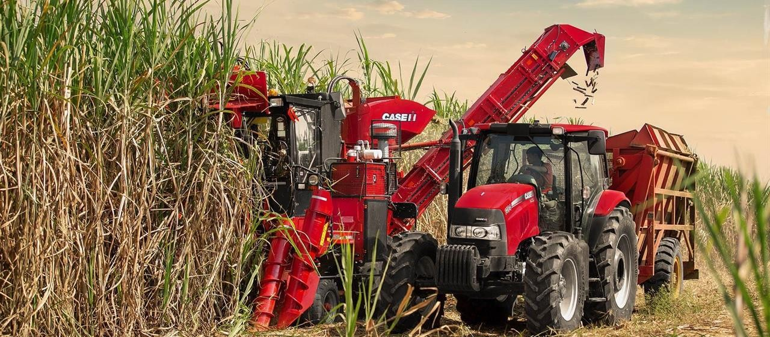
- Name the crop shown on the photograph. (2mark)
- What is the activity taking place on the photograph.(2mark)
- With one evidence, suggest the scale of production of the crop shown. (3marks)
- List down four conditions necessary for the growth of the crop shown on the photograph. (4 marks)
- Outline four factors that might affect the quality of the photograph given. (4marks)

SECTION C (30 Marks)
Answer two questions in this section
7‘’The ideally census must cover the whole country and all people residing in the country must be counted’’. Suppose you are given a task to educate your society about census. Why would you tell people that, it is very important for Tanzanian government to conduct census? (Explain five reasons).

8Plantation is the most form of agriculture practiced in tropical region of Africa, Asia and South America. Justify six characteristics of plantations practiced in these areas.
- Discuss six efforts that Tanzania must adopt to make tourism industry very potential for our national

THE UNITED REPUBLIC OF TANZANIA PRESIDENT’S OFFICE
REGIONAL ADMINISTRATION AND LOCAL GOVERNMENT FORM FOUR EXAMINATION - SERIES 03
GEOGRAPHY
Time 3:00 Hrs YEAR: 2022

INSTRUCTIONS

- This paper consist of sections A, B and C
- Answer all questions in section A and B and only TWO questions in section C
- All answers must be written clearly in the answer sheets provided
- Write your number on every page of your answer sheets
- All writings should be in blue or black ink pen and all drawings by a pencil

FOR EXAMINER’S USE ONLY

Question Number | Score | Initials of the Examiner
01.
02.
03.
04.
05.
06.
07.
08.
09.
10.
TOTAL.
This paper consists of 6 printed pages

SECTION A. (15marks)
Answer all questions in this section.

PHYSICAL AND MATHEMATICAL GEOGRAPHY

- For each of the term(i)-(x) choose the collect answer among the given alternatives and write its letter in the box provided.
  - The area with the high pressure are called
    - cyclonic
    - cyclones
    - anticyclones
    - syncline

  - The extensive highland areas with more or less uniform summit level bounded by one or more steep slope side is called…………..
    - Plateaus
    - Hill
    - Residual
    - Basin
  - is the slow but steady movement of weathered material
    - mass wasting
    - soil creep
    - mudflow
    - Avalanches

  - The agricultural system that takes place on the small area using advanced technology so as to get high product………………………
    - Mixed farming
    - Arable farming
    - Intensive farming
    - Extensive farming

  - The industry which deals with the making the new products from the processed raw materials………………………………….
    - Fabricating industries
    - light industries
    - processing industries
    - Manufacturing industries

  - Thermal metamorphisms is caused by
    - Intensive heat
    - Pressure
    - Wind and heat
    - At morphemic pressure

  - which wave causes the surface rocks to move from side to side ,at right angles to the direction of the wave motion,
    - primary wave
    - secondary wave
    - love wave
    - Raleigh wave

  - Volcano which solidifies around the vent and make dome shape is known as………………………………………
    - shield volcano
    - basic lava cone
    - Acidic lava cone
    - plateau

  - When the local time in Dar es salaam (45oE is noon what will be the local time in longitude in London (00 E )
A. 4:08 p.m
B. 1:52 pm
C. 09:10am
D. 10:03 am

  - The side of a mountain facing the direction of the wind is known as………
    - leeward side
    - fore side
    - Backward side
    - wind ward side E.
- Match the items in COLUMN A with the corresponding items in COLUMN B against its corresponding number in COLUNM A.
Column A | Column B
- Water that flows out of the ground  - Strato –volcano  - The evidence to prove the earth is spherical.  - Escarpment fault.  - Weathering | - steep slope that face down thrown in the faulted land scape.  - Acidic lava cone.  - Decomposition of the rock that is exposed on the earth’s surface.  - Spring  - vertical fracture produced when two rock side against one another  - large cone with alternate layer of pyroclasts steep slope.  - Well  - The luner eclip

SECTION B (55) Marks
Answer all questions in this section

- Write short notes on the following
- What is sampling ,
- Mention and explain six sub types of sampling techniques as applied in research
- Outline four characteristic of good hypothesis

- (a) Define the following terms as used in chain survey
  - Triangulation
  - chaining (iii)offset (iv)Ranging
(v) Offset rod

(b)Briefly explain the function of the following tools as used in surveying

- chain
- Ranging pole (iii)Cross staff (iv)Arrows
(v) Pegs (vi)Survey’s band

- Carefully study the statistical chart below, then answer the questions that follows

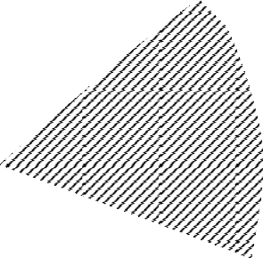Gold

Copper Tanzanite Diamond
Silva

- Fill the table below,

Type of mineral |  |  | Number of mineral in 000 | Degree
Gold | - |  | - | -
Copper | - |  | - | -
Tanzania |  | - | - | -
Diamond |  | - | - | -
Silva | - |  | - | -
TOTAL |  |  | 3600 | 360

- Comment on the trend of the mineral production from the above table.
- Name the type of statistical chart used.
- Write down the advantages and disadvantages of the diagram

- Study the map of MTILI sheet of 232/4 and answer the question bellow

- Describe the settlement pattern in the map sheet provided
- With the good example give distribution of vegetation found in the map provided
- Use example from the map provided describe drainage pattern found in the map.
- Giving evidence from the map suggest three economic activities taking place in the area (e)Measure the length of the road from grid reference (575600 to 594724) .
- Study the photograph

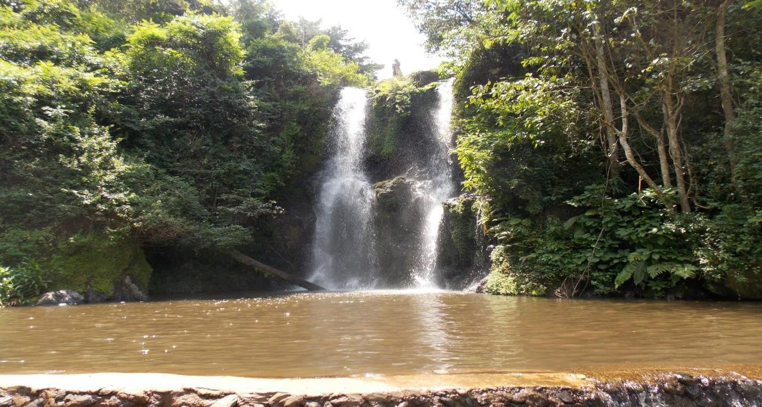

  - With two reasons comment on the type of climate shown bellow
  - Name the type of photograph.
  - Describe and explain the main physical features found in the photograph.
  - Examine four economic importance of the features shown on the photograph.

SECTION C; (30 Marks)
Answer two questions in this section

- Describe six causes of Biodiversity
- Explain five factors for population change in Tanzania
- Explain in detailed, Why Tanzania takes long time to establish hydro Electric power ,at Rufiji river system (striglers gorge power)?

TIME: 3 HOURS

QUESTIONS

THE UNITED REPUBLIC OF TANZANIA PRESIDENT’S OFFICE
REGIONAL ADMINISTRATION AND LOCAL GOVERNMENT FORM FOUR EXAMINATION - SERIES 04
GEOGRAPHY

INSTRUCTIONS:
- This paper consists of three sections A, B and C with a total of 10 questions.
- Answer all questions in section A and B and any two (2) questions from section C.
- Map Extract of MKOMAZI (SHEET 109/1) IS PROVIDED.
- Non programmable calculators and other authorized materials are allowed in the examination room.
- Write your examination number on every page of your Answer booklet(s).

SECTION A :( 15 MARKS).
Answer all questions in this section.
- For each of the item (i) – (x), choose the correct answer from the given alternatives and write its letter besides the item number in the answer booklet provided.
  - Forces that affect the earth’s crust leading into formation of anticlines and synclines are called:-
    - Tectonic forces B. Tensional forces C. Compressional forces
D. Gravitational forces E. Pulling forces ( )

  - Mr. Jackson Chacha decided to construct a map with each 2 centimeters representing 8.4 kilometers on the ground. What is a representative fraction scale did he put on his map?
A. 1:840,000 B. 1:420,000 C. 1:420,000 D. 1cm:84km E. 2:8.4

  - The seasonal fluctuation of a river in its volume is known as:-
    - River capture B. River Basin C. River profile D. River Rejuvenation
E. River Regime

  - A person who studies how the earthquake occurs, its effects and proposes precautions to take is known as…..
    - A Seismologist B. A Geologist C. Geomorphologists
D. An epicenter technician E. A Seismographer

  - The permanent movement of people with animals in search of water and pasture is called:-
    - Nomadism B. Transhumance C. Sedentary Pastoralism
D. Seasonal grazing E. Permanent grazing

  - The factor that does not affect the water supply is…………..
    - Superstition works B. Rapid Population C. Water Pollution
D. Low supplying technology E. Poor government support

  - What is the local time of town ‘S' (65⁰E) when it is noon at another town ‘R’ (40⁰E). A. 10:40am B. 06:40am C. 1:40pm D. 1:40am E. 12:40pm

  - Life expectancy is……………………………………………………………
A. Expected years someone can live B. Ability to afford health cure
C. Ability to become rich D. To live without diet problem E. living without facing wars

  - Features on topographical maps are presented by…………………………………………………
    - Form lines and sport heights B. Sport heights and optical square
C. Hill shading and scales D. Piece of paper and compass E. None

  - is the last stage in a research process
    - Data collection B. Data presentation C. Report writing
D. Piloting E. Research design

- Match the descriptions of weathering in List A with the correct response in list B by writing the letter of corresponding response besides the items number in the answer sheet provided.

LIST A | LIST B
i. Is a process whereby blocks of rocks | A. Carbonation
breaks away from the original rock | B. Plucking
mass along lines of weakness. | C. Hydraulic
ii. This is a process in which rain water | D. Acidic rain
reacts directly with certain type of | E. Block separation
rocks. | F. Attrition
iii. It is common in crystal growth. | G. Exfoliation
iv. A feature of Karst scenery region | H. Tafoni
v. The combination of sulphuric acid and | I. Solution
rainwater | J. Suspension
 | K. clints

SECTION B (55 MARKS).

Answer all sections questions.

- Use the map extract of Mkomazi to answer the following questions.

  - Find the bearing and direction of Kwamiali grid reference 923803 from Mkomazi grid reference 980868
  - With reasons explain three economic activities that seem to be taking place on the given map.
  - Express the scale of the map as statement scale in meters.
  - State the (2) types of transport observed from the map (e)Calculate the area covered by the seasonal swamps.

- Cash crops production in Tanzania 2013-2019.
 | Years | sisal | cotton | coffee | Tea
 | 2013 | 113 | 42 | 53 | 14
 | 2014 | 105 | 67 | 45 | 17
 | 2015 | 92 | 50 | 53 | 17
 | 2016 | 81 | 56 | 49 | 18
 | 2017 | 86 | 60 | 48 | 17
 | 2018 | 74 | 59 | 67 | 16
 | 2019 | 10 | 12 | 11 | 13
- Name the two simplest way of presenting the data.
- Explain the three advantages and two disadvantages of presenting the data by simple methods mentioned in (a).
- Present the given data by using the compound bar graph.

- In 2016, form four students from Kagera Secondary School conducted a research about road accidents between Bukoba and Mutukula. Finally they submitted a report to the head of school (11marks)
  - What are the main two objectives of that research?
  - Propose four possible research tools which might be used in data collection.
  - Outline three possible problems that faced them when collecting data.
Page 4 of 7

(d) List down two significance of conducting that research.

- (a) Mary is a good cartographer she intends to produce a contoured map of Dar es Salaam. What type of survey method would you advise her to apply?
- Apart from producing contour maps, what is the other significance of the types of survey you have mentioned in (a) above? (3marks)
- Differentiate chain survey from leveling by using the knowledge you have acquired from survey (3 marks)
- List down two ways in which survey is significant in the day to day life of a human being (2 marks)

- Carefully study the following photograph and answer the questions that follow.

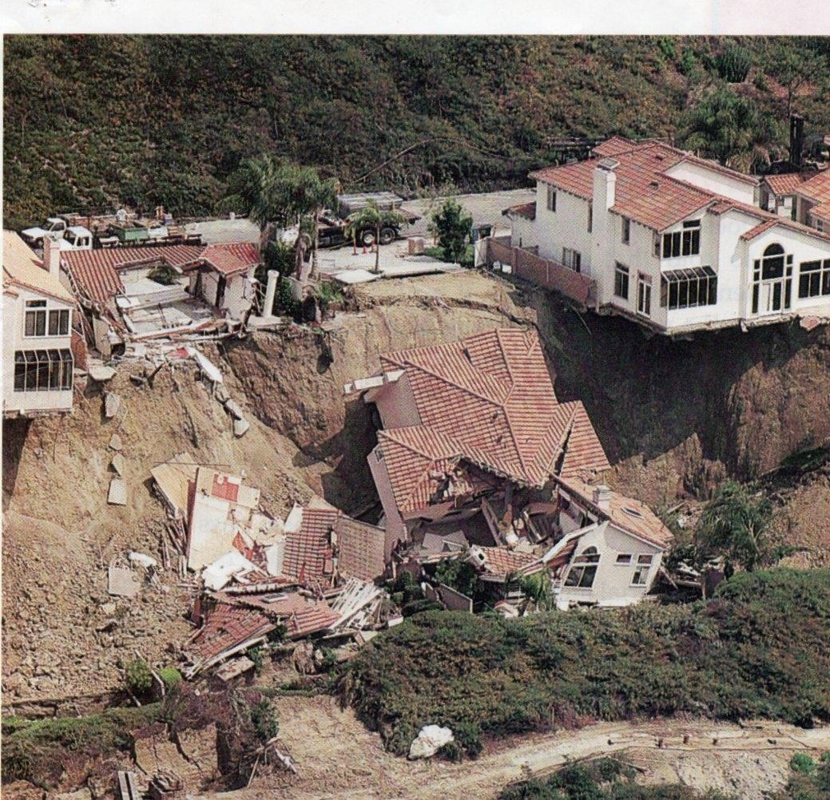

  - Name the type of a photograph.

  - What type of mass movement from your observation?
  - Suggest (3) factors for the movement you have mentioned in (b).
  - Give (3) effects brought about by the type of mass movement mentioned in (b)

SECTION C (30 MARKS).
Answer (2) two questions from this section.

- The record of manmade activities leads to environmental destruction and climatic changes. Use the knowledge obtained from geography suggests six ways to solve climatic problems.

- Anna was a student at Kemebos Secondary School. She studied geography from form one to form four. She got an A of geography in her form four national examination of 2019. Suggest six reasons to why Anna studied geography.

- Explain six push factors causing the rural-urban migration.

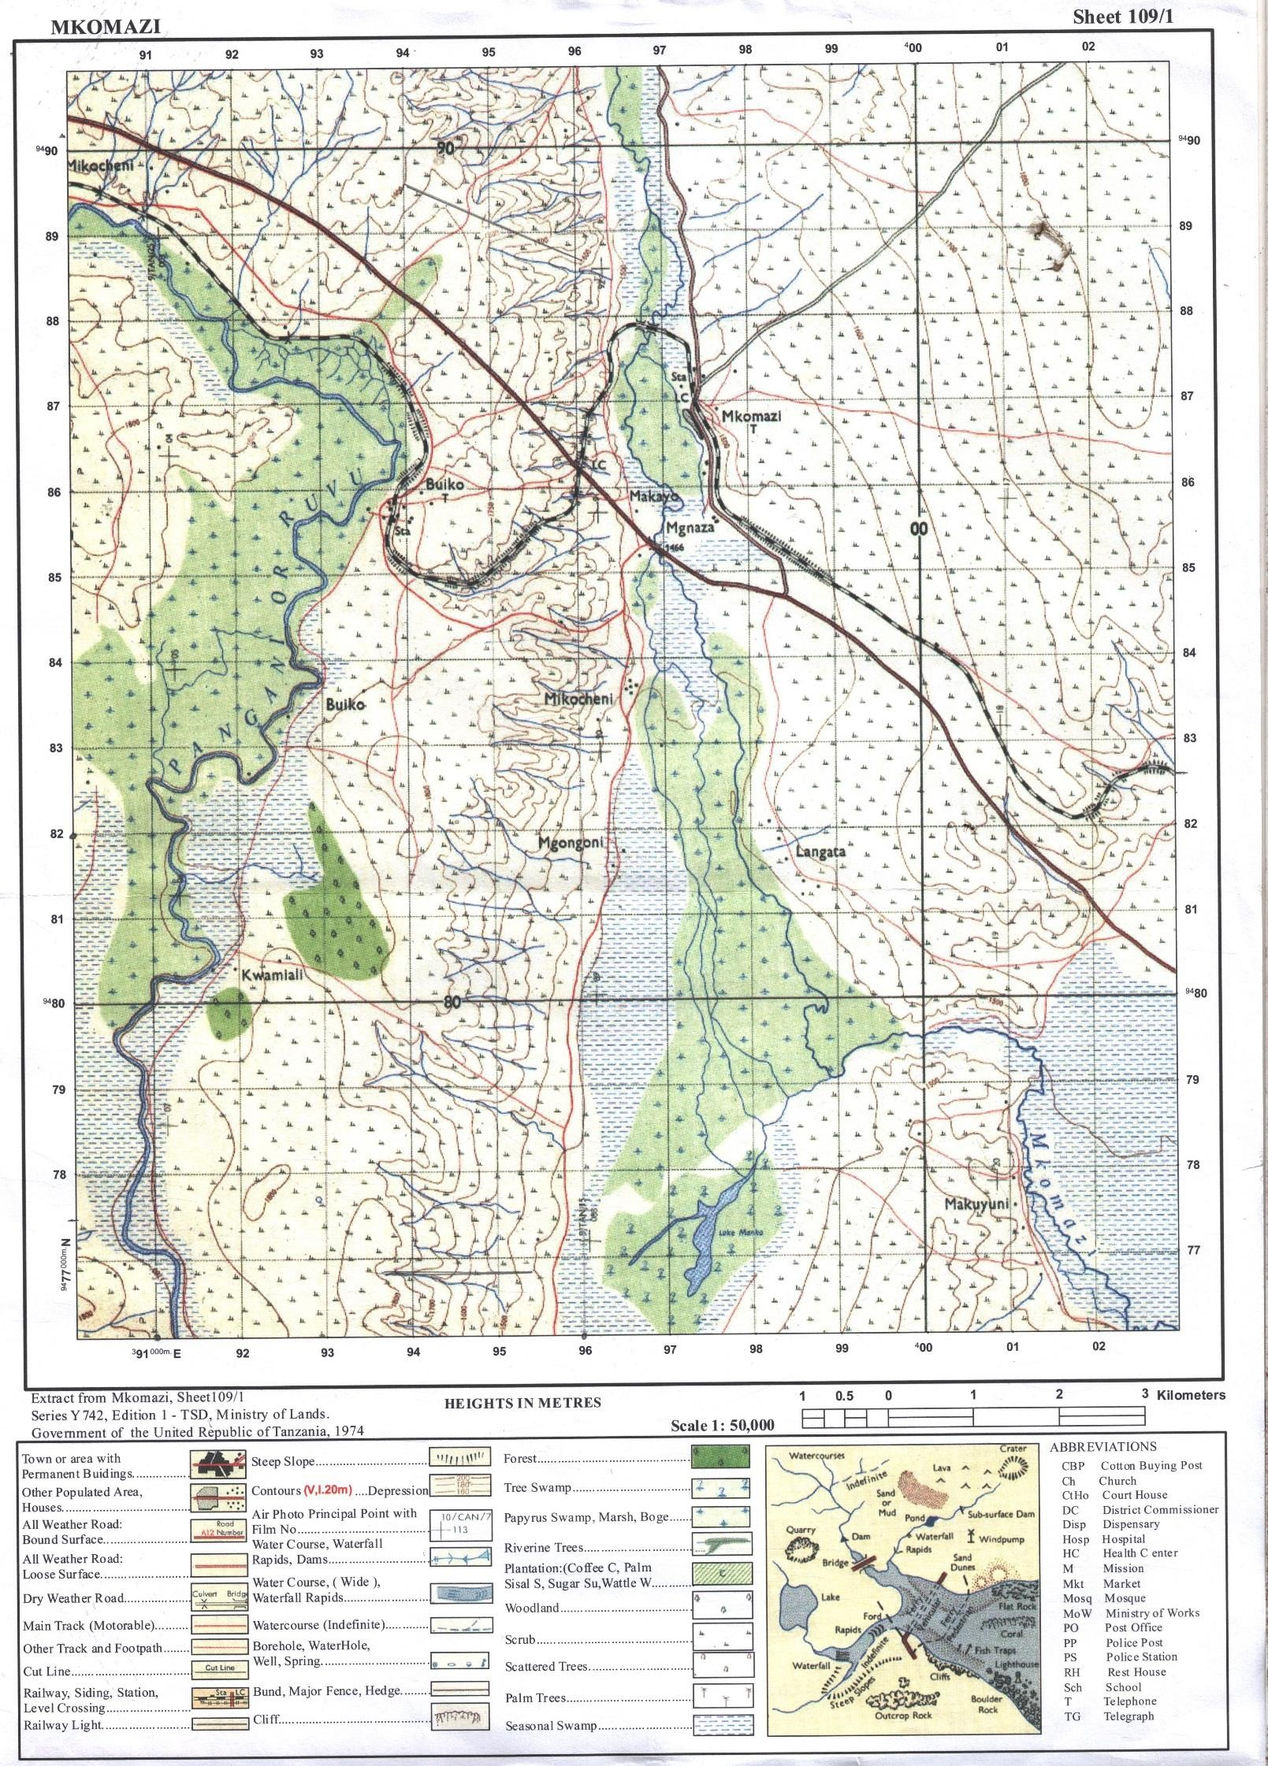

Page 7 of 7

QUESTIONS

THE UNITED REPUBLIC OF TANZANIA PRESIDENT’S OFFICE
REGIONAL ADMINISTRATION AND LOCAL GOVERNMENT FORM FOUR EXAMINATION - SERIES 05
GEOGRAPHY
TIME: 3HRS INSTRUCTIONS
- This paper consists of Section A, B and C with a total of ten (10) questions
- Answer ALL questions in section A and B and any TWO (02) questions from Section C
- Read carefully the instructions given under each section
- Write your examination number on every page of your given answer sheet(s)
- Map extra of SONGWE RIVER (sheet 244/3 is provided.

SECTION A. (15 Marks)
Answer all questions in this section.

- For each of the items (i – x), choose the most correct answer from among the given alternatives and write its letter beside the item number in the answer booklet provided.
  - The slow movement of soil particles which can be recognized by bending of trees and fences is termed as.
    - Land slide B. Soil erosion C. Rock fall D. Soil creep E. Mud flow
  - The T.M.A announced the temperature of Dar es Salaam 100m above the sea level is 29℃. What will be the temperature of Dodoma 800m above sea level?
A. 33.2℃ B.20.8℃ C. 32℃ D. 24.8℃ E. 4.2℃
  - The blanket of air surrounding the Earth’s surface is called.
    - Lithosphere B. Hydrosphere C. Troposphere. D. Mesosphere
E. Atmosphere
  - Amani is a form three student, he conducted a simple research about rocks. In his research, he observed that some rocks expand when get heat and contract when get cold, hence lose their outer particles. What is the geological process he observed?
    - Weathering B. Block disintegration C. Exfoliation D. Frost action
E. Pressure release.

  - Which one of the following is not associated with earthquakes?
    - Body waves B. Richter scale C. Seismograph D. Geyser E. focus

  - Lukumay is a university student who conducted his research in the societies where the areas are occupied by water that resulted to the lack of land for Agriculture and settlements. Which method should be advised the societies to overcome the challenges?
    - Land conservation B. Land reclamation C. Land policy method
D. Plantation method. E. Agro – forest method.

  - The pattern of population in an area at given time is called.
    - Population change
    - Population size
    - Population structure
    - Age sex
    - Population distribution
  - What is the social-economic advantage of mining in the societies?
    - Transport and communication B. Development of industries
C. Development of agriculture D. International relationship
E. Good government policy.
  - An overhead sun occurs on the tropic of cancer at?
    - 21st June B. 21st March C. 22nd December D. 23rd September
E. 23rd June
  - A Stevenson’s screen is painted by white color in order to?
    - To reflect solar radiation B. Be seen clearly C. Decorate it.
D. Allow thermometer’s to be placed. E. Allow air movement.

Match the item in List A with the correct response in list B by writing the letter of the correct response beside the item number.

LIST A | LIST B
- A mass of magma which has emerged on the earth’s surface.  - A wall like feature formed when magma cuts across a bedding plane.  - A sheet of magma which lies along a bedding plane.  - A very large mass of magma which often forms the root of a mountain.  - A dome-shaped feature formed when magma push up the overlaying layers. | - Laccoliths  - Caldera  - Sills  - volcano  - Lava  - crater  - Dyke  - Cone let  - Batholiths  - Lava cones

SECTION B. 55 Marks
- Study the map extract of SONGWE RIVER (sheet 244/3) and then answer the following questions.
- Measure the length of railway line from grid reference 070120 to 128123.
- Name four physical features found on the area.
- Calculate the area covered by forest in 𝑘𝑚² using grid square method.
- With two evidences suggest the type of climate where the map is taken
- Suggest two types of vegetation found in the area.

Study the data of milk production from Biharu diary in 2009 – 2013 and answer the questions that fallows.
Year | 2009 | 2010 | 2011 | 2012 | 2013
Litres | 40 | 60 | 80 | 90 | 110

- Present the above data using divergent bar graph
- Mention two (02) merits and demerits of the graph
- Apart from the method used above describe other two methods to present the data above
- Calculate
  - Mean
  - Median

- a). Differentiate between Intersection from Resection
- Describe any three disadvantages of chain survey in geographical studies c). Identify any four sources of errors when conducting chain survey.

- a) State four characteristics of research hypothesis b). Differentiate primary data and secondary data
- Identify four (04) objectives of conducting research in Tanzania.

Carefully study the following photograph and answer the questions that follows.
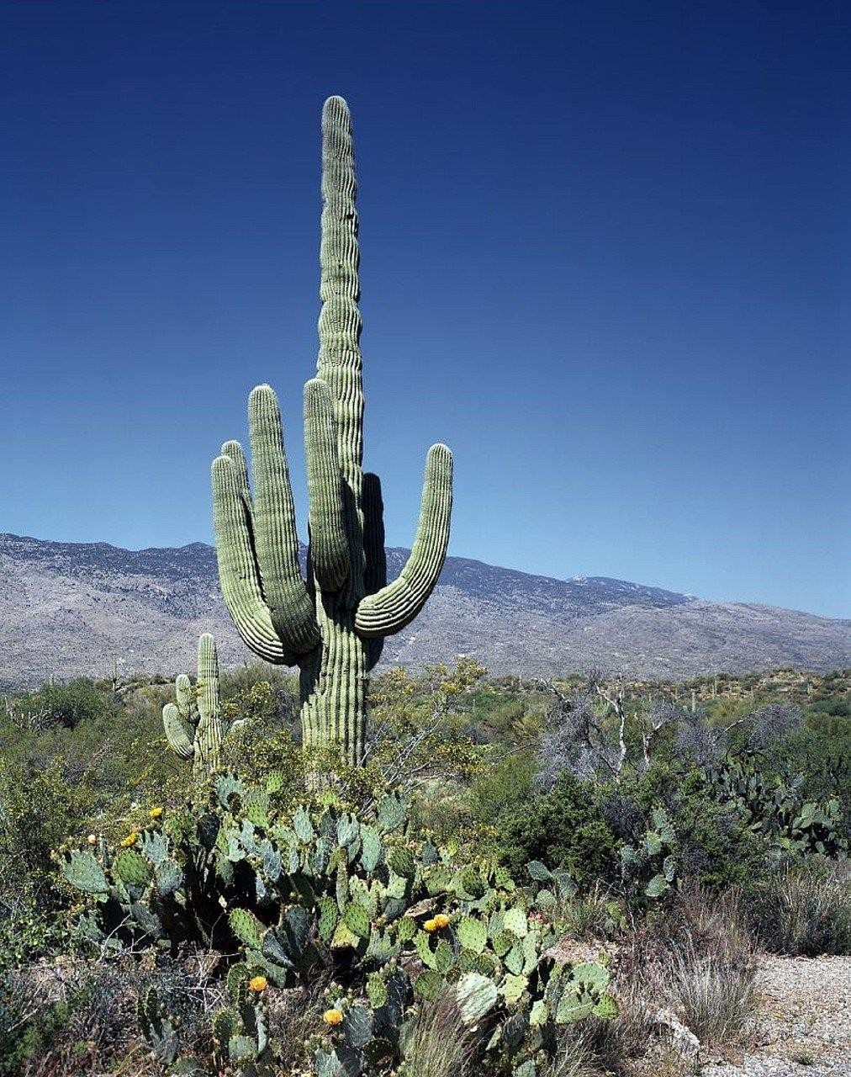
- What is the name of dominant trees?
- Suggest three possible regions in Tanzania what the photograph have been taken.
- Suggest climatic condition that favor such type of dominant trees.
- Name three relief features shown on the photograph
- Name two land uses that might be taking place in the area.

SECTION C (30 Marks)
Answer any two questions from this section.

- Identify any six setbacks of large scale agriculture in Tanzania.

- Kichachani was talking with her child who believes that the temperature was affected worldwide. By using six evidences, describe how Kichachani will prove to her child that temperature can be affected by several factors

- Most of the East African Rivers are not suitable for navigation purpose. Justify this statement by six points.

CODE: 013
BABATI TOWN COUNCIL
FORM FOUR PRE - MOCK EXAMINA TION — 2020
GEOGRAPHY



Yime: 3Hours Date 10/08/ 2020 p.m

INSTRUCTIONS:
1, This paper consists of section A, B and C with total of ten (10) questions.
- Answer all questions in section A and B and any two (2) questions from Section C
- Map sheet of Mkomazi (sheet 109/1) is provided.
- Write your Examination number on every page of your answer sheet provided.

SECTION A (15 Marks)

Answer all questions in this section.

- For each of the items (i) — (x) choose the correct answer from among the given alternatives and write its letter bisede the item number in the answer sheet provided

  - Line that are drawn on the map joining dlPerent places with the same height above the sea level are called:
    - Altitude B. Latitude C. Contours D. Isohytes E. Isobars
  - When do we get the Summer Solstice in the Southern hemisphere?
    - 23’^{d} September B. 21 ^{t} June C. 22nd December D. 21^ March
E. 21st September
  - Which of the following is the evidence which proves that the ealh is spherical?
    - The lunar eclipse B. The four seasons C. The revolution of the ealh D. The eclipse of the sun E. The Equator

  - The Intesity of an earth quake is measured by an instrument called:-
    - Epicentre B. Chronometer C. Seismography D. Richter Scale
E. Mercalli scale
  - Chalinze at Sea level has a temperature of 32⁰C. What is the temperature of

Babati 1500M above the Sea level?
(A) 19⁰C (B) 9⁰C (C) 0.6⁰C ( D) 17⁰C (E) 23⁰C

1

- Amina was wondering on mount Kwaraa large amount of soil and rock materials
were sliding down ward. What is geological processes were occurring in that mountain.
  - Weathering and erosion (B) Deposition and transportation
(C) Mass wasting and transportation (D) Weathering and denudation
(E) Erosion and transportation

  - After learning different types of Soil texture form three Students were asked to identity the best type of soil which can be mixed with cement for building a house. What type of soil will be picked by the students who understood the lesson?
(A) Clay (B) Loam (C) Sandy (D) Silt (E) Alkaline soil

(Viii)
Suppose you want to carry out a field study on atmospheric condition suitable for growth of baize in your Village. What are the best components of weather your going to consider?
(A) Rainfall and soil (B) Nloisture and Sunshine (C) Rainfall and Clouds Cover
(D) Temperature and Rainfall (E) Humidity and Rainfall

- At first time, Jamali was travelling by bus from Arusha to f1wanza after reaching to Singida was supprised by observing a large rock masses like an Onion. What geological processes occurred to such rocks?
  - Denudation (B) Exfoliation (C) Block disintegration
(D) Granular disintegration (E) thermal expansion

( ) Within your Village there is land conflicts between pastoralists and farmers. You as a graduate Land Surveyor, what is the best type of Land Survey will you apply to overcome this conflicts?
(A) Plane table survey (B) Prismatic Compass Survey (C) Chain and tape Survey (D) Levelling (E) Cadastral Survey

Nlatch the items in list A with the responses in list B by writing a letter of the correct response beside the item number in the answer sheets provided.

LIST A | LIST B
- Fineness and coarseness of soil particles  - Studies the properties and distributes of soil  - Degree of acidity or alkalinity in the soil  - Ability of the soil to support plant growth  - Skillful use or wise utilization and control of quality of soil. | - Soil Conservation  - Soil Management  - Soil fertility  - Soil erosion  - Solum  - Soil texture  - Soil erosion  - Pedology  - Soil reaction

2

SECTION B (55 Marks)

Answer all questions in this section
- Study the map extract of Mkomazi (sheet 1o9/1) and then answer the following

questions:-
- By using the given RF Scale, Measure the distance of River Pangani in Kilometres

from grid reference 910771 to 910826,
- Describe relief, nature of the area
- With reasons, identify two types of rocks found in the map.
- Name the major way used to show the height of the land in the mapped area.

Give any three (3) supportive contents of a topographical map given.
  - Suggest the climate of the mapped area (Give two evidence)

- Hamis and 3uma were selling school bags. They always record data of their retailing in a note book. Their friend 4ames is working in a supermarket as a store keeper and he told them about the simplest way of presenting data for a single variable against time. James showed his friends the following table showing data of school bags received from 2001 to 2007.

Year | 2001 | 2002 | 2003 | 2004 | 2005 | 2006 | 2007
School bags Received | 90 | 100 | 40 | 50 | 20 | 70 | 120

- Name the two simplest ways of presenting the data
- Explain five advantages of presenting the data by simple methods mentioned in (a)
- Present the given statistical information by using simple graph.

There was a Land conflict between villagers of Magugu and the headmaster of Magugu Secondary School. The village chairperson decided to invite a survey team who used chain/tape survey to determine the boundaries of school compound.

Describe five instruments they .used in surveying the school compound
- Explain three procedures they followed during survey process.

- Give brief account of the following data collection techniques as used in field research
with examples.
  - Questionnaire
  - Interview
  - Focus group discussion method

3

Carefully study the following photograph and then answer the questions that follows:

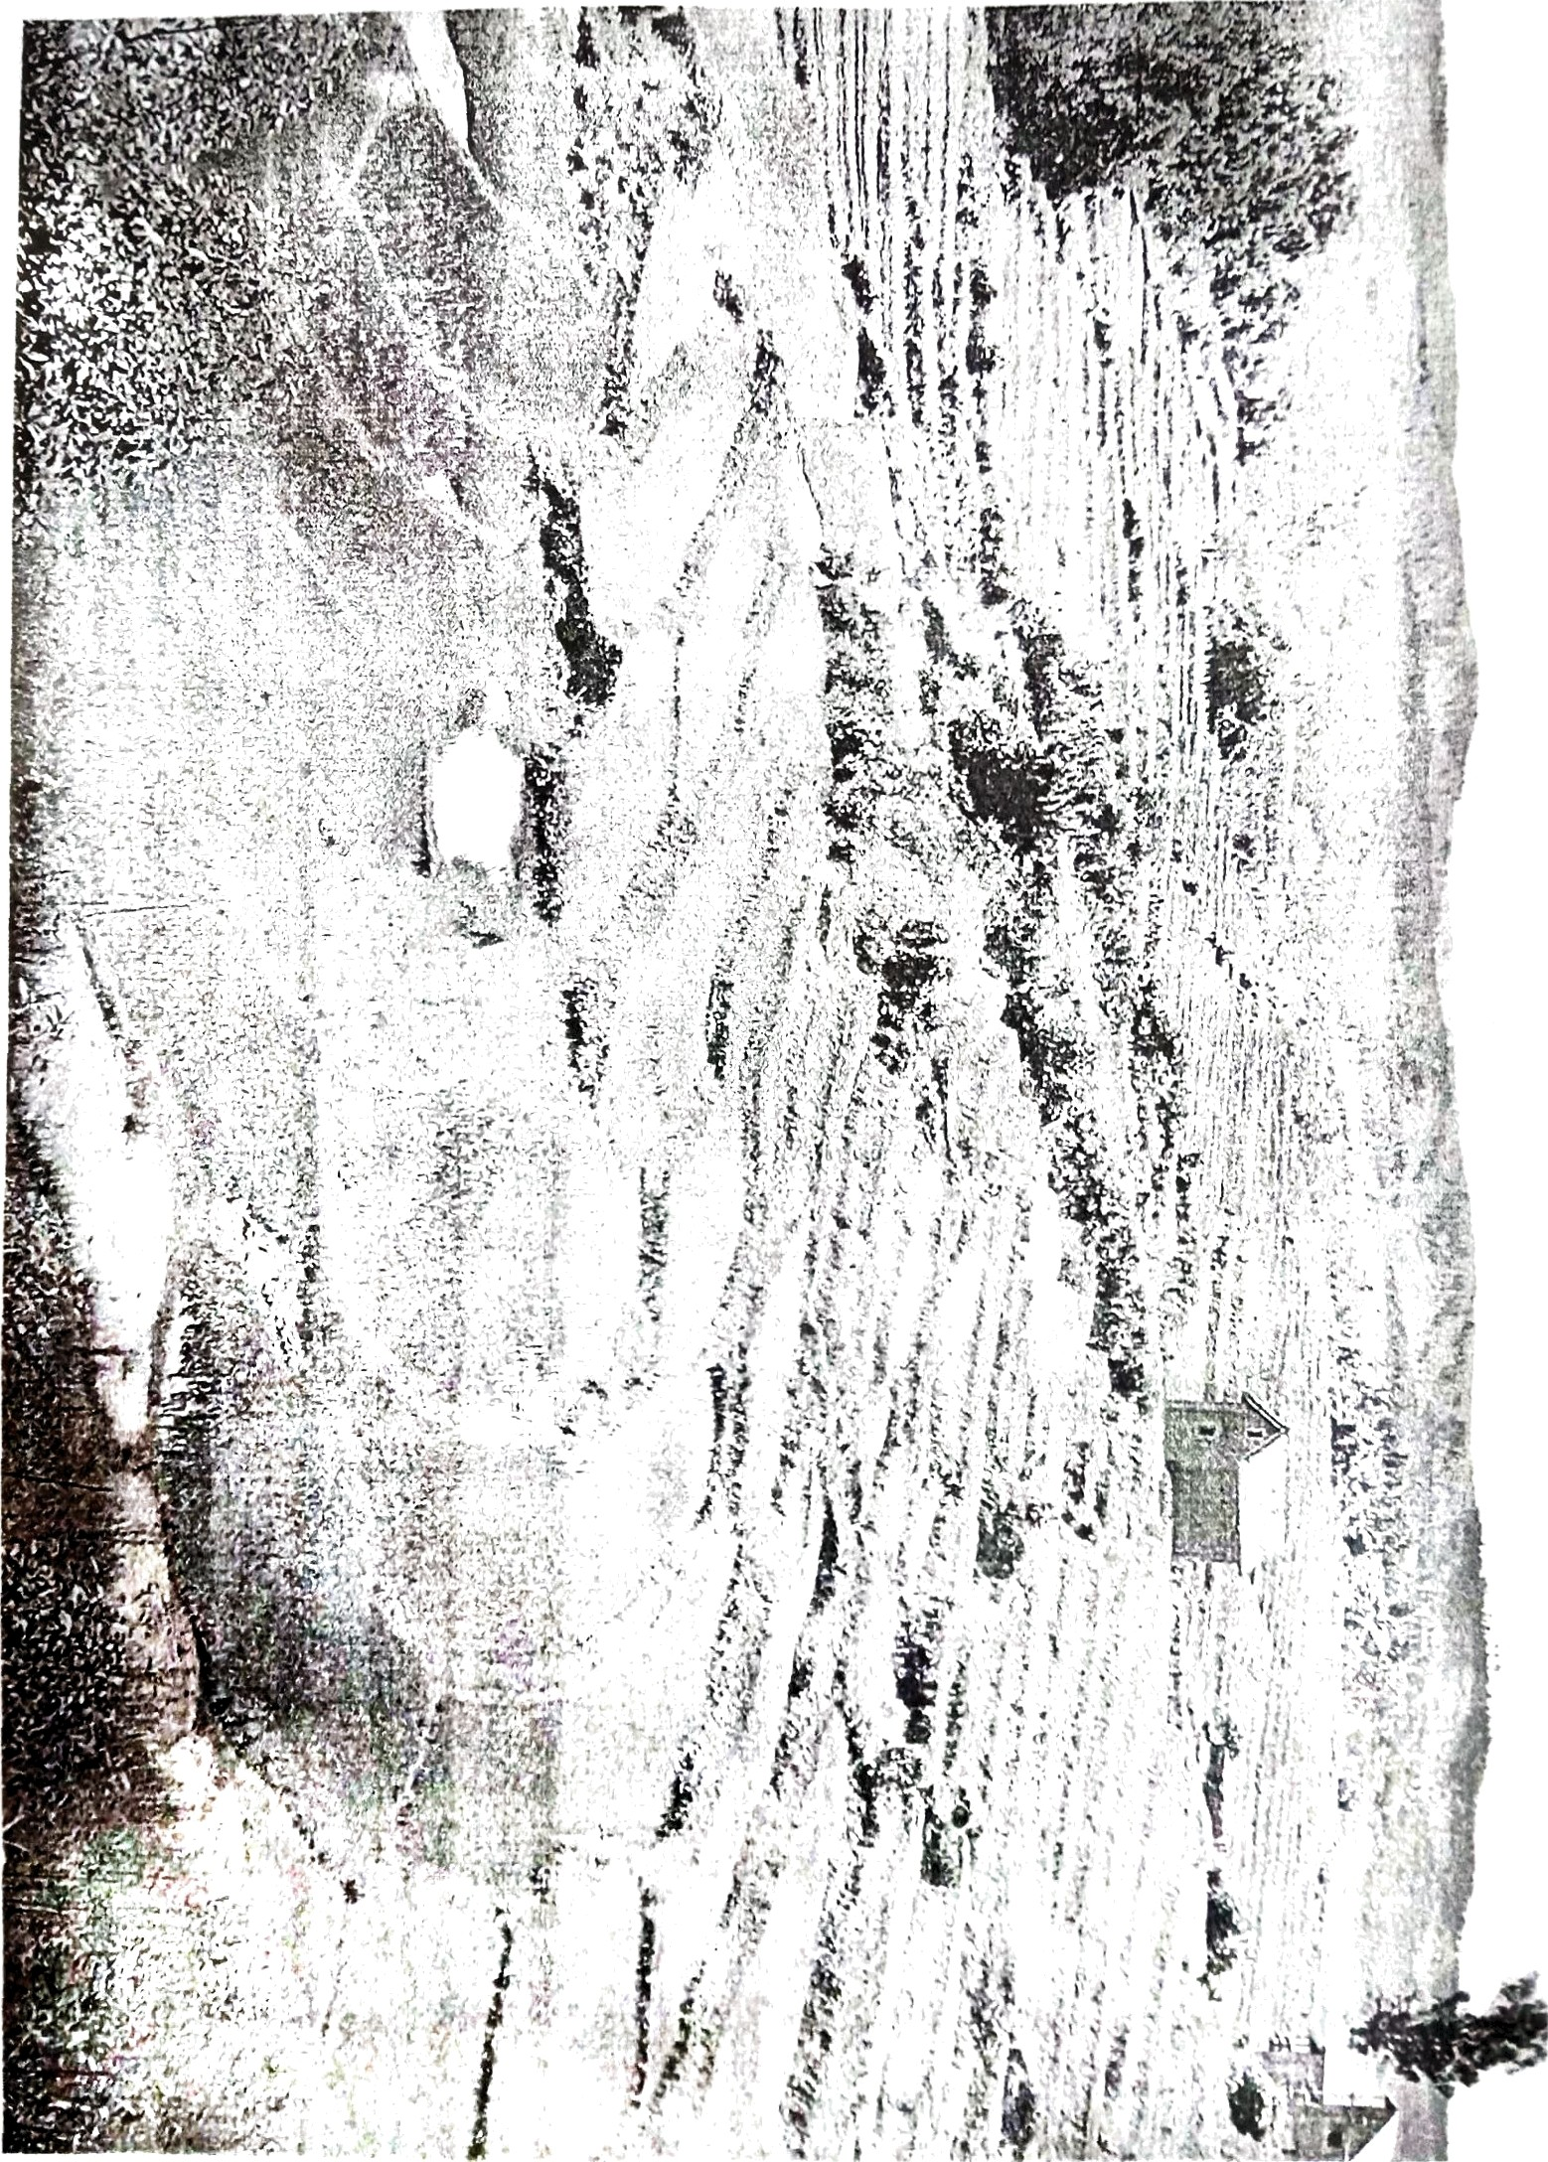

  - Identify the type of photograph with two reasons.

Describe the relief features shown in the photograph
  - Name the land use opted in the photograph
  - Why they opted such land use in C above
  - Name two possible crop can be grown in the photograph

SECTION C (30 Marks)

Answer two (2) questions from this section

- For a long time crop producer in East Africa Countries failed to satisfy food demands. Identify six causes of this sholcoming with reference to Tanzania.

- Forest is among of natural resources in Tanzania has been naturally gifted. Explain six value of forest resources to Tanzania.

- Discuss the reasons for low level of industrial development in Sub Saharan African Countries. Give six points.

5

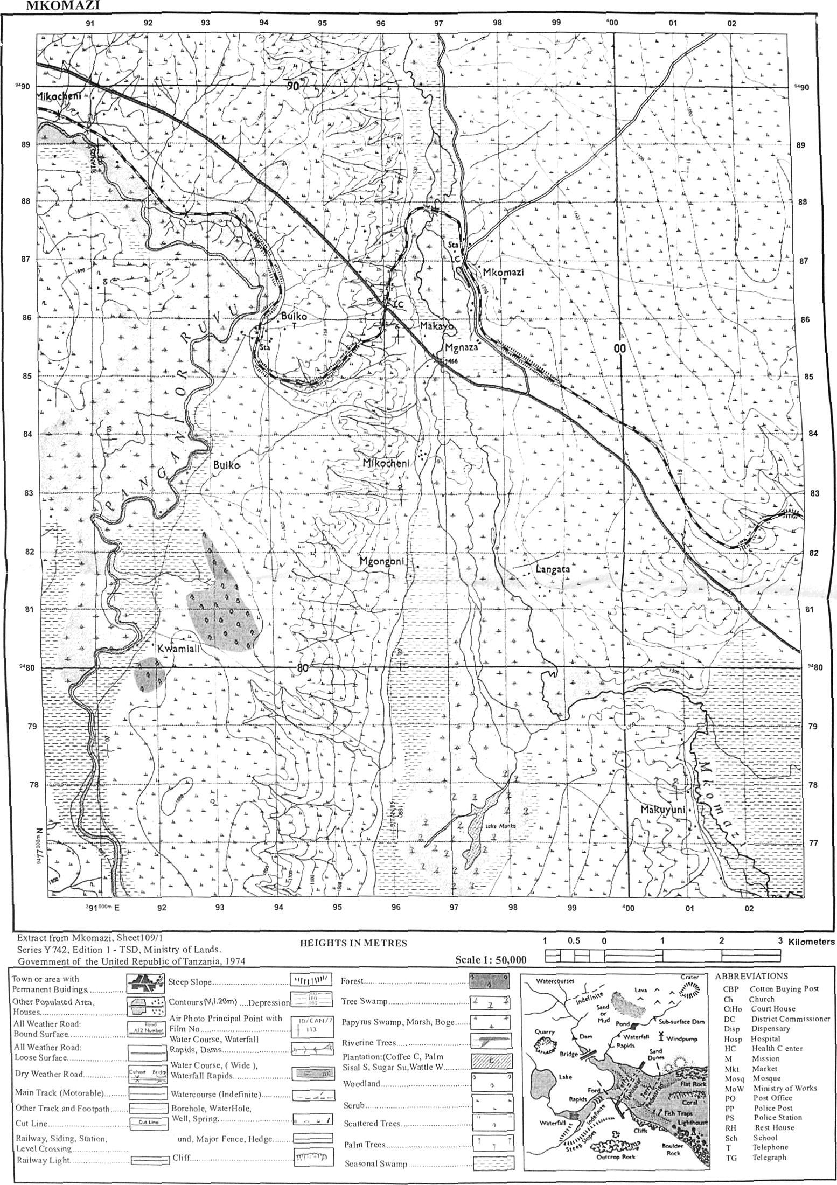Sheet 109/1

QUESTIONS

THE UNITED REPUBLIC OF TANZANIA PRESIDENT’S OFFICE
REGIONAL ADMINISTRATION AND LOCAL GOVERNMENT FORM FOUR EXAMINATION - SERIES 07
GEOGRAPHY

Time: 3 Hours
Instructions

- This paper consists of three sections A, B and C with a total of 10 questions.
- Answer all questions in section A and B and any two (2) questions from section C.
- Map Extract of MKOMAZI (sheet 109/1) is provided.
- Non programmable calculators and other authorized materials are not allowed in the examination room.
- Write your examination number on every page of your Answer booklet(s).

SECTION A: (15 MARKS).
Answer all questions in this section.
- For each of the item (i) – (x), choose the correct answer from the given alternatives and write its letter besides the item number in the answer booklet provided.
- What are the social economic advantages of reserved forest to societies?
  - Lumbering B. Tourism C. Agriculture D. Mining E. Forestry
- Mr. Jackson Chacha decided to construct a map with each 2 centimeters representing
8.4 kilometers on the ground. What is a representative fraction scale did he put on his map?
A. 1:840,000 B. 1:420,000 C. 1:420,000 D. 1cm: 84km E. 2:8.4
- The seasonal fluctuation of a river in its volume is known as:-
  - River capture B. River Basin C. River profile D. River Rejuvenation
E. River Regime
- One of the items is not components of the solar system
  - Sun B. Planet C. Plateau D. Meteoroids E. Asteroids
- The permanent movement of people with animals in search of water and pasture is called:-
A. Nomadism | B. Transhumance | C. sedentary pastoralism | D. Seasonal
grazing | E. permanent grazing
- The factor that does not affect the water supply is
  - Superstition works B. Rapid Population C. Water Pollution
D. Low supplying technology E. Poor government support
- What is the local time of town ‘S'(65⁰E) when it is noon at another town ‘R’ (40⁰E).
A. 10:40am B. 06:40am C. 1:40pm D. 1:40 am E. 12:40pm
- Life expectancy is
  - Expected years someone can live B. Ability to afford health cure
C. Ability to become rich D. To live without diet problem E. living without facing wars
- Features on topographical maps are presented by
  - Form lines and sport heights B. Sport heights and optical square
C. Hill shading and scales D. Piece of paper and compass E. None
- is the last stage in a research process
  - Data collection B. Data presentation C. Report writing D. Piloting
E. Research design

- Match the items in list A with the responses in list B by writing the letter of correct response beside the item number in the answer booklet provided
LIST A | LIST B
- A layer of igneous intrusion which is vertical that cut across bedding planes of the crustal rock  - A dome-shaped igneous intrusion with a flat floor  - Is the largest intrusion of all igneous intrusion  - A column made up of very viscous lava and which stands above the general ground like pillar.  - Is a funnel-shaped volcanic depression which forms at the upper end of a volcanic | - Phaccolith  - Batholiths  - Caldera  - Crater  - Lacolith  - Lapolith  - Plug domes  - Lava plateau  I. Dyke  J. Sill

SECTION B (55 MARKS).
Answer all sections questions.
- Use the map extract of Mkomazi to answer the following questions.
  - Find the bearing and direction of Kwamiali grid reference 923803 from Mkomazi grid reference 980868
  - With reasons explain three economic activities that seem to be taking place on the given map.
  - Express the scale of the map as statement scale in meters.
  - State the (2) types of transport observed from the map
  - Calculate the area covered by the seasonal swamps.
- Carefully study the following information in the table below that shows the number of students at Luco Secondary School and then answer the questions that follows:
FORM I | FORM II | FORM III | FORM IV
60 | 125 | 90 | 35

  - Present the number of students in each class in percentage
  - Draw a pie graph and represent the data provided
  - Define pie graph and outline the advantages of using it

- Mr. McMillan is a chemist; he is interested to conduct a research about beverage to see the best drinks for human consumption. His plan is to consult consumers who were
directly involved in the consumption and visit other scholar’s written documents for more information
  - What will be the best research approach for his study

  - Name the main sources of data for his study

  - Suggest the question of his research

  - Mention other six possible sources of research problem for the similar study

- What is chain surveying?
  - In short, explain the stages of conducting chain surveying
  - Mention two advantages and disadvantages of chain surveying
- Carefully study the following photograph and answer the question that follow

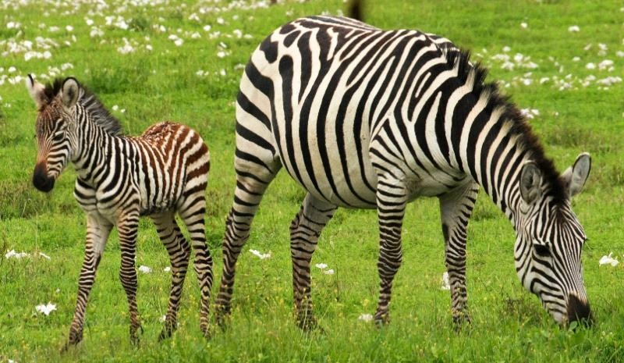
- With evidence name the type of photograph
- What are the environmental problems that might affect the area
- What are the solutions can be taken to overcome in ( b ) above
- Name three areas where the photograph might be taken
- With reasons determine the time at which the photograph was taken

SECTION C (30 MARKS).
Answer (2) two questions from this section.
- “The living environment in Tanzania is suffering at the expense of man's activities.” With the supportive six points, prove this statement
- Explain six ways of improving the industrial base in East Africa.
- We have several sectors to nurture Tanzania development, and one of those sectors is agriculture. Support the above statement by providing six points.

QUESTIONS

THE UNITED REPUBLIC OF TANZANIA PRESIDENT’S OFFICE
REGIONAL ADMINISTRATION AND LOCAL GOVERNMENT FORM FOUR EXAMINATION - SERIES 08
GEOGRAPHY

TIME: 3 HOURS

Instructions
- This paper consists of sections A, B and C with total of 10 questions.
- Answer all questions in section A and B and two (2) questions from section C.
- Section A carries fifteen (15) marks, section B fifty five (55) marks and section C carries thirty (30) marks.
- Map extract of HANANG (sheet 84/4) is provided.
- Non-programmable calculators and mathematical table are allowed materials in the Examination Room.
- Write your Examination Number on every page of your answer booklet(s)

SECTION A: (15 Marks)
Answer all questions in this section
- For each of the items (i) – (x), choose the correct answer from among the given alternatives and write its letter in the answer booklet provided.
  - Assume you are asked to help the form one student who failed to identify the type of Geography, which deals with the study of physical features. What type of Geography will you suggest among the following?
    - Human and economic geography
    - Practical geography
    - Mathematical geography D. Physical geography
E. Human geography.

  - When traveling in a fast moving vehicle, we notice trees and other objects on both sides of the road moving in opposite direction. This shows that the point of observation (the earth) is moving by rotation from:
    - West to East
    - East to West
    - East to South
    - West to North E. West to South.

  - The layer of atmosphere characterized by 16 kilometer thick at the equator, temperature decrease with an increase in altitude and its boundary with the next layer is known as tropopause. The layer is called:
    - Stratosphere
    - Mesosphere
    - Thermosphere
    - Exosphere E. Troposphere.

  - Mr. Kijazi and their students visit at a certain National Park in Tanzania and see the thick forest, tree dwellers, animals and people who engage in cultivation of cocoa and coffee. What type of forest will you suggest among the following:
    - Tropical Savannah
    - Equatorial
    - Mediterranean
    - Tropical monsoon
    - Polar climate

  - The navigable rivers in East Africa include Rufiji, Ruvuma, Tana and Nile. Unfortunately most of the rivers are of limited use for navigation for the following reasons:
    - Rapids or water falls
    - Large amount of silt
    - Large volume of water
    - Presence of dangerous animals
    - Some rivers disappear.

  - Mr. Mengi was interested in developing energy from the remains of living organizations, what will be the best raw materials for Mr. Mengi’s project?
    - Coal
    - Petroleum
    - Natural gas
    - Solar energy E. Running water.

  - Form three students at Mnazi Bay Secondary school make survey in Kondoa district and identify different types of soil erosion. One of the following is not a type of soil erosion: A. Splash erosion
- Sheet erosion
- Lateral erosion
- Rill erosion E. Gully erosion.

  - Exfoliation is the process of peeling off rocks, one of the cause of exfoliation is:
    - Bush fires
    - Running water
    - Air in motion D. Hydrolysis
E. Hydration.

  - From 2015 Tanzania is struggling to transform her economy from agricultural based to industrial based, but one of the effects of industry base economy is pollution. Identify four (4) types of pollution which caused by Tanzania industry.
    - Soil, water, noise and air pollution
    - Nuclear, land, noise and air pollution
    - Radiation, water, air and noise pollution
    - Air, noise, water and nuclear pollution E. Radiation, land, noise and nuclear pollution.

  - A coral is the limestone rock formed below the low level tides as the result of the deposition of skeletons of minute sea organisms called polyps. The polyps survive in the following conditions:
    - Muddy salty water
    - Calcium carbonate mineral in water, 60m below mean sea level, aerated water, hot sea water and extensive long shore movement
    - Muddy river water about 5ºC to 10ºC of the water and 30m to 40m depth
    - Sunlight, rock platform, warm ocean water, mean sea level and se organisms
    - Salty sea water, about 20ºC to 25ºC aerated water, planktons and 30m to 40m depth of the sea.

- Match the descriptions of settlement in LIST A with the correct answer from LIST B by writing the letter of the correct response beside the item number in the answer booklet(s) provided.

COLUMN A | COLUMN B
- The settlements whereby most people are predominantly engaged in extractive activities such as fishing and forestry  - The actual piece of land upon which a settlement is built  - The settlement pattern whereby buildings are spread out or scattered  - This is the process in which a population is transformed from a rural based agriculture lifestyle to urban based non-agricultural lifestyle  - Overcrowding in cities because of great availability of employment and good health services. | - Factors influencing the growth of settlement  - Dispersed settlement pattern C. Problems associated with urban growth D. Urbanization  - Urban settlement  - Settlement site  - Rural settlement

SECTION B: (55 Marks)

Answer all questions in this section

- Study the map extract of HANANG sheet 84/4 and then answer the following questions:
- Calculate the approximate area of Balangida (salt and soda) lake on the mapped area in kilometer squares.
- With evidences from the map, identify three main ways used to depict relief features on the mapped area.
- Relate main relief features and settlement pattern shown on the mapped area.
- With reasons, describe three rock types shown on the map.
- State vertical contour interval (V.I) used in this topographical map.
- By using evidences on the map, discuss four main land use pattern shown on the mapped area.

- Carefully study the table below, then answer the questions that follow:
Class | Frequency
55 – 59 | 8
50 – 54 | 5
45 – 49 | 10
40 – 44 | 5
35 – 39 | 2
TOTAL | 30

Calculate:
  - Mean value
  - Median
  - Median class
  - Standard deviation

- “Research is a systematic process and it involves a logical manner in order to obtain a meaningful and reliable information”. Justify this statement by giving the first eight (08) stages of research process.

- (a) Define the following terms as applied in survey:
  - Chain survey
  - Offsets
  - Tie line

(b) By giving reasons, describe the importance of surveying in our daily life.

- (a) (i) By using diagram show the three main parts of ground photographs. (ii) Describe main distinctive features of oblique photographs.

- Mr. Msemakweli is a professional photographer at your school, he wanted to produce form four photo-entry form and identification cards for all form four students at your school.
  - Identify the type of photograph that Mr. Msemakweli was likely to take.
  - Describe three advantages and disadvantages of the photograph named in (b) (i) above.

SECTION C: (30 Marks)

Answer two (2) questions in this section

- Ash and Cinder cone, composite cone, crater and Caldera are among of the extrusive volcanic features. To what extent are volcanoes useful and disaster to man or human being? (Three points each).

- Forests have significant contribution to social, economic and ecological development. They provide various products for human use such us timber, poles, wood, logs and honey. With examples explain six (6) points, what is likely to happen if the forest is cleared or destroyed?

- The term “climatic change” refers to all forms of climatic inconsistency and it can occur abruptly or gradually. Describe six (6) impacts of climatic changes to the societies.

QUESTIONS

THE UNITED REPUBLIC OF TANZANIA PRESIDENT’S OFFICE
REGIONAL ADMINISTRATION AND LOCAL GOVERNMENT
NAMANGA SECONDARY SCHOOL
FORM FOUR SPECIAL EXAMINATION - SERIES 01
GEOGRAPHY
TIME: 3HRS
Instructions

- This paper consists of sections A,B and C with total of ten (10) questions.
- Answer all questions in sections A and B and two (2) questions from section C.
- Credits will be given for the use of relevant sketch maps and diagrams.
- Write your examination names on every page of your answer sheets.

SECTION A (15 MARKS)
Answer all questions in this section
- For each of the following items (i) – (x), choose the correct answer from among the given alternatives and write its letter beside the item number on the answer sheet provided.
  - The time of town X (35ºE 10ºN) is 5:00pm.What will be the time of town Y (10ºW 25ºS)? A 08:00pm
B 02:00pm C 02:00am D 03:00pm E 08:00am
  - A great circle refers to:
A a line of longitude B a circle on the globe C the shortest distance
- A circle on the globe whose plane passes through the center of the globe.
- Greenwich meridian only
  - Which one of the following is planetnearest to the solar system?
A Mercury B Venus
C Earth
D Mars
E Saturn
  - The temperature of Karatu 1500 meters above sea level is 23ºC. What will be the temperature of Micheweni at sea level?
    - 19ºc
    - 9ºc
    - 0.6ºc
    - 32ºc
    - 17º
  - Water that enters the rocks of the earth’s surface A Water cycle
B Ground water C Spring
D Juvenile water E Oases
  - If the location of a point on a map is given by grid reference 365490, then: A 490 are northings
- 365 are degrees
- 365 are longitudes D 490 are eastings
E 365 are northings

  - The earth’s layer which is rich in magnesium and iron is: A Sial
B Core C Mantle D Crust
E Sima
  - Water vapour is turned into water droplets in the process known as: A Convection
B Transpiration C Saturation
D Condensation E Evaporation
  - A process of change in composition or structure of a rock by heat or pressure is: A Weathering
- Vulcanicity
- Metamorphism D Mass wasting E Lithification
  - Slate , marble, granite, limestone, chalk, coal and Rock salt are examples of: A Chemically formed sedimentary rocks
B Organically formed sedimentary rocks C Mechanically formed sedimentary rocks D Sedimentary and igneous rocks
E Metamorphic, igneous and sedimentary rocks

- Match the items in List A with corresponding response in list B by writing the letter of the correctanswer beside the item number in the answer sheet provided.

LIST A | LIST B
i. A process by which wind transport | A. Lopolith.
loose materials. | B. Saltation.
ii. Part of the land that lies between high | C. Deflation.
tides water and low tides water. | D. Shore.
iii. One of the components of soil. | E. Coastline.
iv. A volcano made of viscous lava. | F. Artesian basin.
v. Saucer-shaped structure of permeable | G. Composite cone.
rock laying between two | H. Inorganic matter.
impermeable rocks. | I. Soil porosity.
 | J. Cumulous dome.

SECTION B (55 marks)
Answer all questions from this sectio
3(a) Suppose you were given the map scale of 1:50000 ,present into verbal scale
(b)With examples explain how you can identify the following on Topographical map.
i. Climatic region of the place
ii.Rock type
. (c) Mention four procedures used to calculate the area covered on the Topographical map.

(d) Identify four ways used to locate the position of different places on this topographic ma

- Shaukani got the following scores in Geography examination in the year 2020. He wanted to summarize the scores in a simple way so that he shows the rise and fall of the scores across time.
January test – 88 February test – 75 March test – 65 April test – 86 May test – 80 June test– 30
July test -55
August -60 September test – 50 October test – 70 November -65
December test– 45

- What is the best way Shaukani can use to show the rise and fall of his scores in Geography?
- Draw the graph as suggested in 4(a) above.
- Mention two other ways for summarizing the scores above.
- List down four advantages of the method used in 4 (a) above.

- a)Explain the meaning of chain surveying.
b)Describes five (5) principles of conducting chain surveying.

- Most of Tanzanian are experiencing environmental pollution particularly in Towns.As a researcher,conduct a brief research on how we can overcome the problem by answering the following.
- Suggest a suitable title of your research,
- Suggest two objectives of your research,
- Suggest two methods that will use in data collection,
- Suggest two problems that you have experienced during research.

- Carefully study the photograph given below and then answer the questions below.
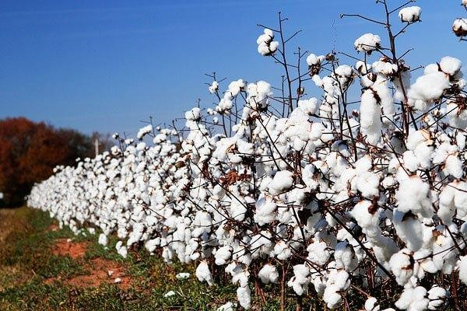
- With two evidences ,suggest the type of photograph.
- Name the crop shown on the photograph.
- Outline any two problems facing the production of the crop shown in the photograph.
- How the Tanzania Government boosts the production of the crop shown in the photograph? Give two ways.

SECTION C (30 Marks)

Answer two questions from this section.

- Industries are not built anywhere. Using six points what are the determinants for the location of any industry.
- Mashimba’s grandmother used to cultivate many crops in a small area using local seeds, a hand hoe and manure. She is now blaming that in five years the harvests are poor. She is complaining that her neighbors are the ones causing it. With six points, explain to her how she can improve her farming system.
- Population has a tendency of increasing inversely proportion to the resources, some demographers argued that Population growth has many positive effects than negative. Show the negative impacts of rapid Population to the country like Tanzania (6points).

QUESTIONS

THE UNITED REPUBLIC OF TANZANIA PRESIDENT’S OFFICE
REGIONAL ADMINISTRATION AND LOCAL GOVERNMENT FORM FOUR EXAMINATION - SERIES 10
GEOGRAPHY
TIME: 3HRS
Instructions

- This paper consists of sections A,B and C with total of ten (10) questions.
- Answer all questions in sections A and B and two (2) questions from section C.
- Credits will be given for the use of relevant sketch maps and diagrams.
- Write your examination number on every page of your answer sheets.
- Map extract of KOROGWE (Sheet129/2) is provided.
- Programmable calculators, cellular phones and unauthorized materials are not allowed in the examination room.

Answ
- For each of the items (i) — (x) and write its letter in the answer

Form three students were taken
Marks)
selion
among the given alternatiVes
by their geography teacher to an eroded area
of the following features might be seen by

near their school comp_{Cl}U0d. WhiCh oFgll
students?

Gullies
  - Hot spring
  - Dyke
  - Geysers
  - Abrassion
    - Chain survey is very importa Fl t iD OLIr d»4r lire as it helps in measuring distances
and areas. One of the following sets comprises instruments used in chain survey
      - Barometer, pegs, notebook and CompaSs
      - Arrows, ranging, poles, pegs and tape
      - Chain, cross staff and anemometer
      - Chain, arrows, ranging poles and anemometer
      - Cross staff, notebook, chain and plane table
    - Vulcanism can lead to the formation of different features. These features can be
grouped into
      - Batholith, dykes and volcano only
      - Many parts according to the nature of lava

Sills, dykes, valleys and earthquakes only
      - Volcanic mountains and sills only
      - Extrusive and intrusive features.

    - Form four students were watching a Television program on various human activities in Kokotoa village. Which among the observed activihes is not the cause of environmental destruction in that village?
      - Charcoal burning
      - Lumbering
      - Firewood cutting
      - Afforestation
      - Construction activities

    - A region which consists of thI‹k rorcsLs, true dwellers and people who engage in
cultivation of rubber, cocoa, bananas and oil palms is known as:
      - Tropical savanna
      - Tropical monsoon
      - Polar climate
      - MediDeranean
      - Equal:orial

    - Which of the following is not a process of chemical weathering?
      - Carbonation
      - Saltation
      - Hydrolysis
      - Hydration
      - Oxidation

I



(viii)
The WATERCOM industry ordered by the government to use environmental
friendly energy sources in productio n. Wnich energy source could be used in that industry?
- Petroleum
- Nuclear
- Fuelwood
- Coal
- Solar

The following are factors that alTect temperature between Tanzania and Ghana except
- Altitude
- Distance from the sea level
- Cloud cover
- Aspect
- Solar energy

A football match started in town X (76°E) at 4:30pm. What would be the time at town Y on Greenwich meridian where the residents plan to observe the match live as well?
(a) 9:34 a,m

(b) 11: 26 a.m
tc) 11.26 p.m
(d) 9.34 p.m
(e) 9.34 p.m
- The carto9= pher prepares the topographical map of Arusha where Ngorongoro crater must be indicated, Which one among the following yvays will be used to indicate the crater?
  - Form lines
  - Hachures
  - Trigonometrical station
  - Bench marks
  - Spot height

Z. Match the process invol Luc in the rurination of rocks in List A with the type of rock in List B by writing the letter of tnu correct response kcsirJe the it<°n number in answer
booklet provided
LIST A | LIST B
(i) Rock rormed when in‹irgn1‹l St)lI(jIlI‹'*  onthe surace by‹oqun[SUf LfOSOl  (j ) Rocks formed wfic°n  cools and soIidifi<°s on the surface or  the earth  (iii) Rocks formed as results of deposition and compaction of remains of dead plants and animals  (a) Rocks formed when different types ot  rocks are subjected to great heat and  pressure  (v) Rocks formed when sediments a t e  deposited either by water, wind 07 ice | Crystalline rocks Igneous ‹ocks  c: Organic sedimentary rocks  D: Intrusive volcanic rocks  Extrusive volcanic rocks Metamorphic rocks  G: Sedimentary rocks








3

Sectijgrt B' (55 Marks)
Answer all questions in this section
- Study carefully the map extraCt @$ »i»wpaka (sheet 49/1)

and answer the following

questions
  - Express the map scale US
a statemen t scale 6s8et4 to grid reference S565457

  - How long in kil Clmetres is thl? l
oad from grid reférence

Calculate the area covered by
thickets in square kilometres
suggest four economic activities carried out in

By giving evidence from the map,
the area.
- Coral coast cannot develop in all water bodies and not in all parts of continents. Their
development is limied by several conditions. Explain five conditions for the growth of arals.

Mary decided to carry out a research on factors influencing injuries during sports in her school. She decided reading various documen ts on injuries during sports activities.
  - Identify the stage of research that Nary is dealing within her research.
  - Briefly explain six advantages of the research stage concentrated by Mary.
6. Mr Themi is an expert on statistics who has displayed data on the production of oily crops in 2001 by simple pie chart as shown below.

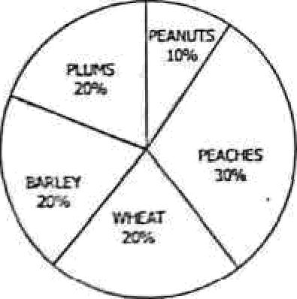
(q) Cajcubte the actual production of the crops in tonnes if the flat production is 1200 Annes
- Present production of I:be crops by divergent line graph.

(a)
{b)
Name three types or geographical photographs.
Specify the types of geographical photograph whlch Is:
  - Taken horizontally on the ground
  - Used in map making

- Write down five differences bcMcen the photograph you have mentioned in (b) (ii)
above and topographlcal maps

SECTION C (30 Plarks)
Answer two (2) questions from this section
- Last holiday Jane decided to visit her grandmother in Dodoma. On her journey from Dar es salaam0 Dodoma she saw some areas having large population, other areas having low population and other areas no population at all. By giving six (6) points, explain factors affecting such distribution of people.

- Annes aunt claims that the study of rocks is wastage of time. Convice her that rocks are very essential by describing six (6) importance of rocks


Tanzania has been sbuggling to revive and improving her industries. Analyze six (6) Wdy5
of promoting textile industry in Tanzania
4

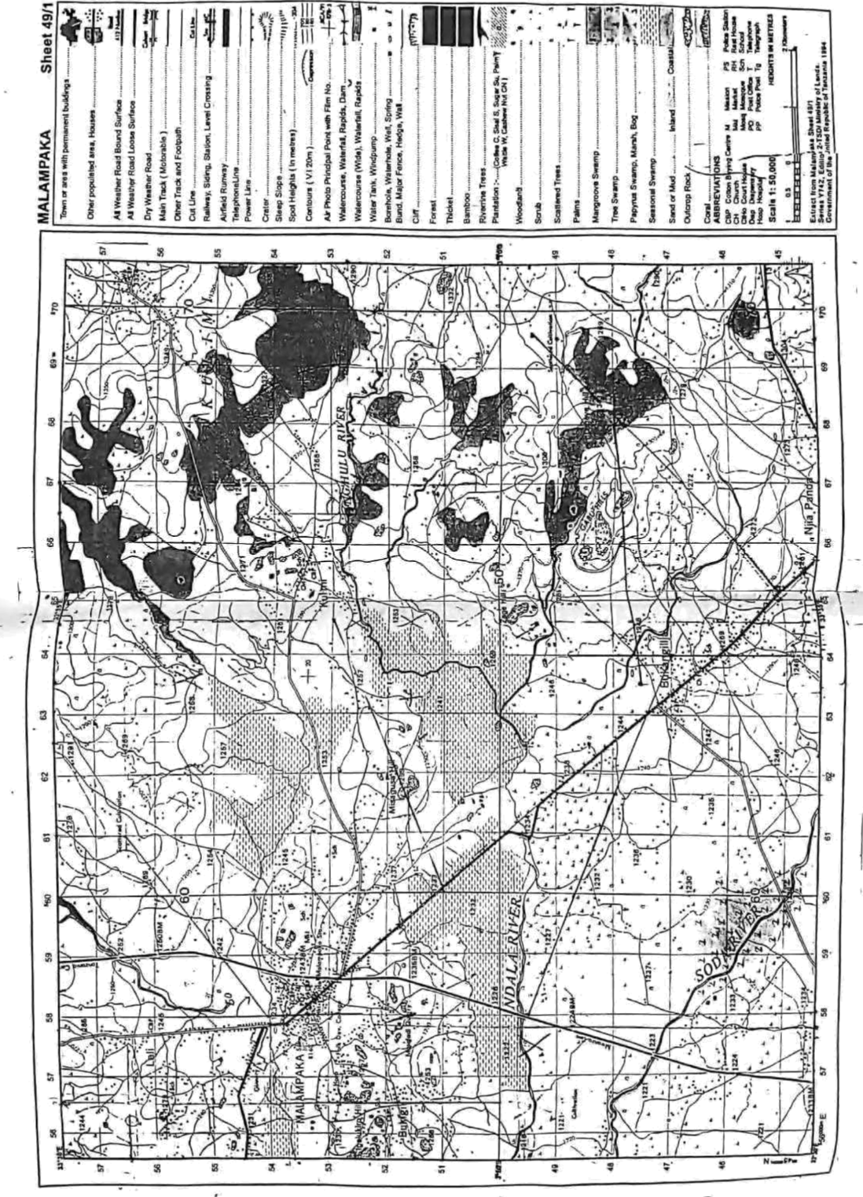

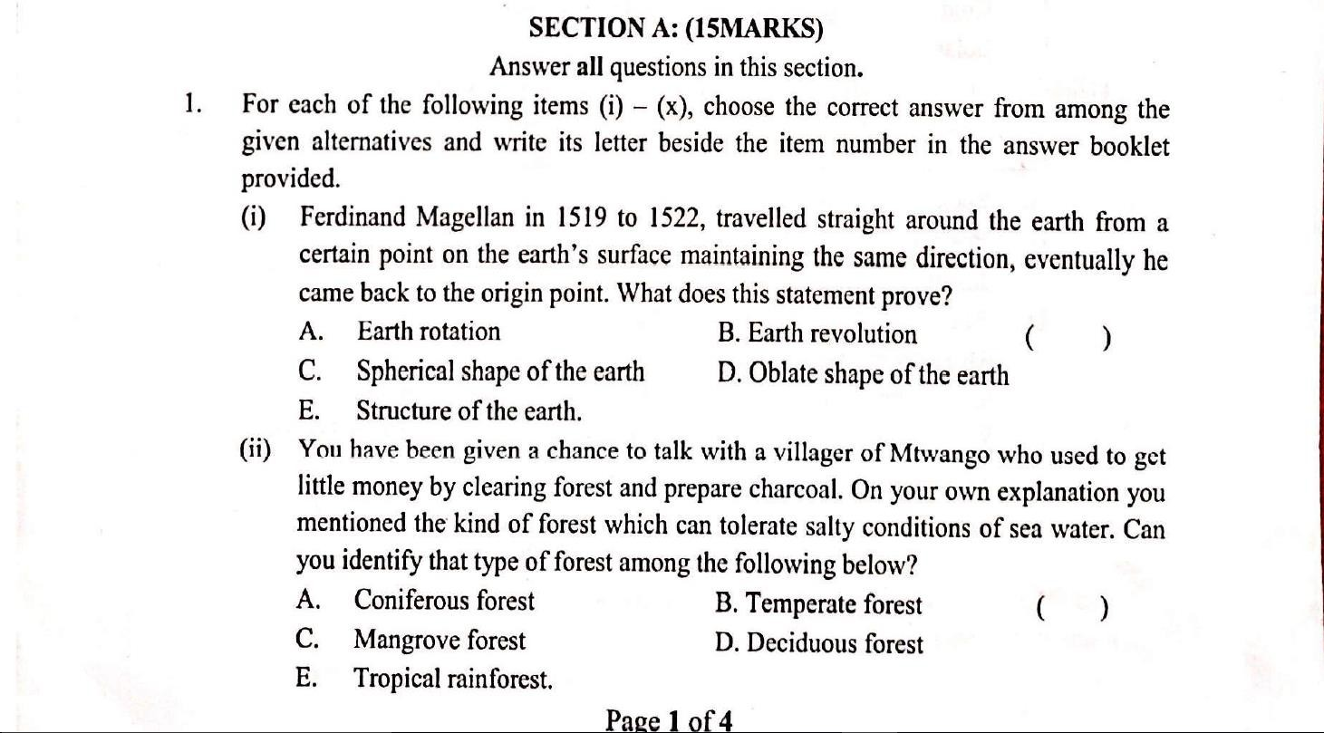QUESTIONS

THE UNITED REPUBLIC OF TANZANIA PRESIDENT’S OFFICE
REGIONAL ADMINISTRATION AND LOCAL GOVERNMENT FORM FOUR EXAMINATION - SERIES 11
GEOGRAPHY
TIME: 3HRS
Instructions

- This paper consists of sections A,B and C with total of ten (10) questions.
- Answer all questions in sections A and B and two (2) questions from section C.
- Credits will be given for the use of relevant sketch maps and diagrams.
- Write your examination number on every page of your answer sheets.
- Map extract of KOROGWE (Sheet129/2) is provided.
- Programmable calculators, cellular phones and unauthorized materials are not allowed in the examination room.

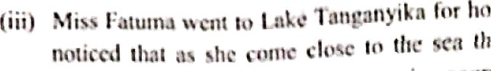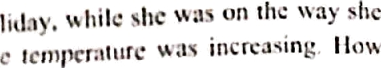

r'Y. Tciuptwiiirv ink cmiiui '' "' '*" " ' """ '
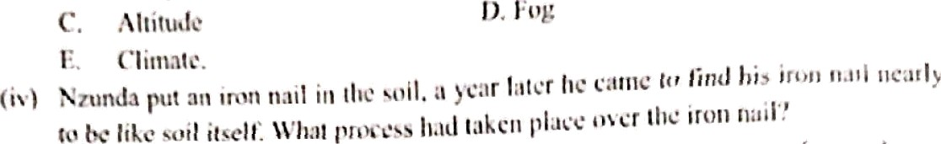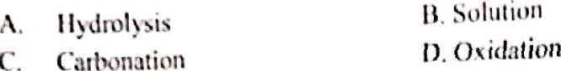

(,.)

(,t

ccng‹stc 1. U‘hal oceanic feature did lie observe?
A. Oceanic island B. An archipt l0gOS (
C. Continental island - Congested islands
E. Continenul shelf.
The Lind of rainfall which falls in hot areas lfkc Def »ss ai«am, by being formed d5 result of differential heating of the tarth surface that cause q;jrm moist air currents lo rise verlically altitudes, then cooling and condensing to form clouds which later
form rainfall. \Vliich type of rainfall is this?
A. Relief rainfall B. Topographical ntinfall ( )
C. Con›'ectiona1 rainfall D. Orographic rainfall
- Frontal rainfall.

(vij) NEMC ordered the owners of sisal factory to use environ jjqental friendly energy sources in produciion. Which energy source could be used in that factory?
A.  C. | Fuel wood  Coal | B. Nuclear  D. Petroleum | ( )
E. | Solar.
Currently the world is facing decline in food production, increase in drought, floods and shortage of hydroelectric power supply. Which among the following reasons contribute lo such environmcnial problems?
  - Social and economic development
  - Problems of climatic changes ( )
  - Impact of reduction of erosion
  - The development of science and technology
  - Diseases and pests control.
    - A Tanzania Foreign Minister was in interview with China through CCTV at (75’W, 42a) at 7:30 pm Tuesday. At what time will people in Dar es salnam, Tanzania (45’E, 06'S) be watching the live TV?
      - 3:30 pm Wednesday B. 8: 30 pm Tuesday ( )
C. 3:30 am Wednesday D. 8:30 pm Wednesday
E. 3:30 pm Tuesday.

Page 2 of4

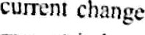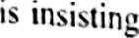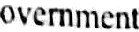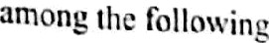
^^
tourism as the remedial for the problcnl. WhiCh
*'* °St importance of green tourism'!
To" ’°hanmFu!cflNtson cnvm nmcn

To hring pca¿¿ •nJ Iutn›Jcny t›fTonxuniali.s
C. To gt*Qg rstu inc‹ me
n. TO c:spcss* the naiinnal atlmcliolts
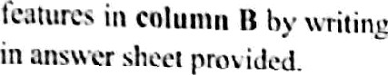E. To cncc1umg•c Hosni(ali(y u£‹I= T•n«»i.ois.
uCtiuil features in column A wilh Ihe corresponding the 1cllcr of lhc cord-ect answer beside lhc ilem number
G. Traction.
Saltation.
/ .
Ws xv’hercby materials carried by wind collide each other.
MTdltlffl Site particles are moved by series of leap and jumps.
(*)
- Abrasion.
- Hydraulic.
c. Suspension.
D. Deflation.
fi. Attrition.
(' )i * 9 S of blow’ing an.'ay dust and sand particles.
scraping and
QDlfSlllng rock surface.
('V)
TmnSp9@r g fine and light •«i‹es being held by nir current abo\e the ground.
(I}
COLUMN B
COLUItlN A

SECTION B: (55MARKfi)
Answer all questions in this section.
  - Study carefully the map extract of Mpwopwa (sheet 163/4) and the answer the following questions.
    - Describe four (04) functions of Mpwapwa.
    - Describe the drainage patterns found on the mapped area.
    - By using square method, calculate the area covered by ihe forest.
    - With evidence from the map given name and explain two types of rocks found in the mapped area.
(c) Explain three (03) importance of a feature shown at grid references 110995.
  - The following are the scores of Geography in form ihrcc midtcrm test done on April 2021 at Igawilo secondary school.
40 | 40 | 7g | 57 | 54 | 65 49 59 65 38 48 55
62 | 50 | 37 | 52 | 38 | 55 60 76 68 56 73 74
83 | 80 | 78 | 65 | 58 | 41.
    - Prepare a frequency distribution table staking wiih smallest class interval of 35-39
    - Calculate the mean and median.
    - Show two (02) significance of arithmetic mesn in geographical data.

  - Form three students visited the riVer mouth of Rufiji River and ihey found that the river pours its water into ltte Indian Ocean by spreading many small channels called distribularies covering a widt flat land with alluvium deposits forming a triangular shaped feature.

(b› identify the fra\tire nhscn'nl fry ft›n›\ hircc sliI‹lrnlr
(h) l?c•<Tif+c £c›ur (IM) c‹›ndilit1tIx l\r‹cssar;' h›r ilic fi›rT›1,1Iic›n nfn fralllrc in (a) abuvc. (c} IJrirfl} explain ft*\ir (UI) iIt\tv›It•cncc HI”n lv.time in (a) o11n\'c.
f7uriny *un”c;iny ynncsx llic sun”c;t re If\Act \\’itli tlill“crtltt uhstaclcs. If yuu arc am‹›ng
the 5un c•yon learn and )'ou iiicvl a pund during }’ilut sun’c y aclii'ily. ta) I lou’ are jou poiatt to orcmuuc thai obsiatlt''
(bl Are the sun ey xkills ihai )ou liai'c leanil ai scli‹u›l uselul in your society?
(cj II ribc three (03) izscfuIncxs oFsur\'c}‘.

- Study carefully the follow ing pholog rpm and ansucr the questions thut %llow.
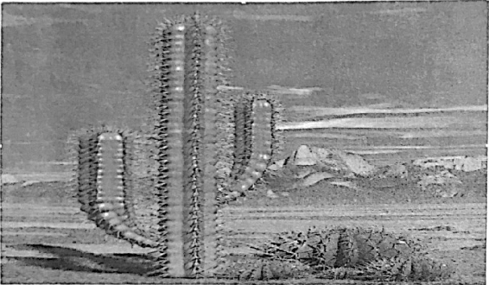
  - Identify the name of s'egetation shown on the photograph.
  - Explain four (m) adnptation mechanism of vegetation shown on the photograph.
  - Identify the type of photograph.
  - Explain three (03) characteristics of type of photograph above.

SECTION C: (30 StARKS)
Answer trio (02) questions from this section.
- In order to get power and energy, Tanzania has to crtate a number of water teservoirs like Mtera, Nyumba ya Mungu, and Kidatu. Describe run tin) advantages and four (04) disadvantages of creating these reservoirs.
- Ideally national census must cover the whole country and all people in the country must be counted. Suppose you are given a task to educate your society about national census, using six (06) points tell Tanzanians about the importance of national census.

! 0.
Mr. Fisher decided to conduct research on loss of biodiversity in Ngorongoro reserved area. He decided to use interview method in collecting data. Explain six reasons as to why he decided to use this method and not others.

Page d of 4



